

**DATABASE & MANAGEMENT SYSTEM LAB**

**LAB 5**

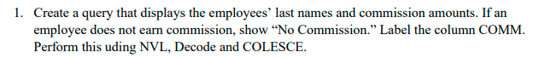

**Query:**

|  |
| --- |
| SELECT ENAME AS "LAST_NAME",NVL(TO_CHAR(COMM),'NO COMMISSION') AS COMMISSION,COALESCE(TO_CHAR(COMM),'NO COMMISSION') AS " COMMISSION COALESCE ",DECODE(COMM,NULL,'NO COMISSION',0,'NO COMISSION (0 )',COMM) AS "COMMISSION DECODE" FROM EMP; |

**Output:**

|  |
| --- |
|  |

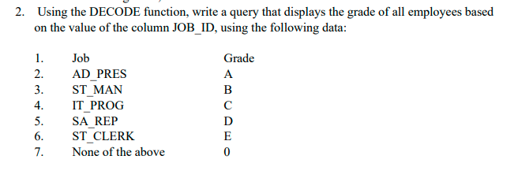

**Query:**

|  |
| --- |
| SELECT ENAME ,  JOB,  DECODE(JOB,'PRESIDENT','A','MANAGER','B','ANALYST','C','SALESMAN','D','CLERK','E',0) AS "GRADE" FROM EMP; |

**Output:**

|  |
| --- |
|  |



**Query:**

|  |
| --- |
| SELECT  JOB AS "JOB_ID",  CASE JOB WHEN 'PRESIDENT' THEN 'A'  WHEN 'MANAGER' THEN 'B'  WHEN 'ANALYST' THEN 'C'  WHEN 'SALESMAN' THEN 'D'  WHEN 'CLERK' THEN 'E'  ELSE '0'  END GRADE  FROM EMP; |

**Output:**

|  |
| --- |
|  |

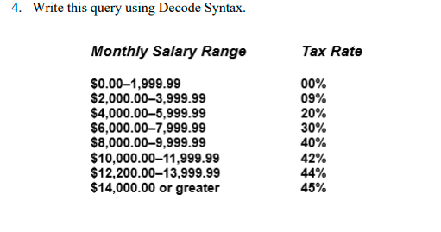

**Query:**

|  |
| --- |
| SELECT  SAL,  DECODE(TRUNC(SAL/2000),  0,'00%',1,'09%',2,'20%',3,'30%',4,'40%',5,'42%',6,'44%','45%') AS "TAX RATE"  FROM EMP; |

**Output:**

|  |
| --- |
|  |